Monte Carlo Increased-Radius Floating Random Walk Solution For Potential Problems

Ali Ihsan Canakoglua,[1]

a Department of Electrical & Electronics Engineering, Dumlupinar University, 43100, Kutahya, Türkiye

ORCID ID: xxxx-xxxx-xxxx-xxxx

**Abstract**

In this paper, a new Monte Carlo walk method is introduced. The increased radius floating random walk combines of the two classical Monte Carlo methods and derived from fixed-radius floating walk method. In this paper, the method is used to solve typical Laplace’s equations in rectangular region. Also, this method is easily applied to Poisson equations. Lower walk number and hence lower computation time are obtained from new method compared with the fixed random walk, floating random walk and fixed-radius random walk methods. The results are also compared with Finite Element Method. Increased radius walk method’s results are good agreement with other methods.

***Keywords:*** “Floating random walk, Laplace equations, Monte carlo method, Numerical methods, Potential problems.”

# Introduction

In many engineering disciplines, calculations of potentials or fields are needed for many problems such as in heat conduction, fluid dynamics and electromagnetics. The mathematical basis and techniques needed are well known, but are often difficult to apply in the complicated three-dimensional geometries. Nowadays finite element method or finite difference methods are widely used for determining the potential and field solutions. It is difficult to use finite-element or finite difference methods to calculate electric potentials or fields near a high-voltage transmission tower, or stress-control fitting, because of the large number of mesh points or nodes needed to give an adequate representation of the geometry. The Monte Carlo methods give a convenient and flexible means of tackling these and similar problems in electrical power engineering, and may also be used for potential theory calculations in other branches of engineering. The goal of the method is to solve Dirichlet’s problem: to find a potential (and its derivatives) which satisfies Laplace’s equation within a given region and takes specified values on its boundary [1]. There are a lot of studies in the literature about Monte Carlo method [2-5]. The Monte Carlo methods are widely used in electromagnetics problems, areas of applications include electrostatics, waveguide analysis and antennas. It is easily applied to Laplace’s and Poisson’s equations in both two and three-dimensional cases [6], and time-dependent problems [7]. There are many types of Monte Carlo method. Some and significant ones are as follows:

1. Fixed random walk

2. Floating random walk

3. Exodus method

The first two methods are the most popular. In fixed random walk, the step size is fixed and steps of the random walks are constrained to lie parallel to the coordinate axes. It takes a long time to compute the potential at a given point. On the other hand, in floating random walk, the step size is not fixed. Hence the computation is more rapid than in the fixed random walk. Yu and friends [8], in their work, two techniques are developed to accelerate the floating random walk method for the electrostatic computation involving rectilinear shapes. Garcia and Sadiku [9] have introduced a new walk procedure in addition to these existing three types, named fixed-radius floating random walk. The aim of this method is to decrease the runtime and to eliminate the need to check for the shortest distance to the border. If the radius of the circle in floating random walk is fixed, then the programming the random walk becomes easier. Thus it is more effective and it reduces the runtime considerably. Although Monte Carlo simulation is a slow and costly technique, it does have some advantages that are as follows:

1. Don’t require input data

2. Conceptually easier to understand

3. Easy programming

The major disadvantage of the Monte Carlo methods is that they permit calculating the potential only one point at a time. For whole field calculations, other numerical techniques such as finite element and finite difference methods are preferred. For whole field computation, several techniques have been proposed such as shrinking boundary method [10] and inscribed figure method [11].

In this paper, a new walk method, namely increased-radius floating random walk, is introduced. This method is based on the fixed-radius floating random walk. In this method, the radiuses of the circles are increased with Δr at every step. Thus, the arriving time to a border is dramatically reduced.

# Monte Carlo Method

The mathematical basis of the Monte Carlo method is easily found in the literature [12]. Briefly, two important concepts serve as a mathematical basis:

1. The mean value theorem of potential
2. Green’s function of the first kind

Also, generating random numbers and application to the Laplace equation in rectangular and axisymmetric regions are given in [13]. Let us suppose that the fixed random walk is to be applied to solve Laplace’s equation:

 in region R (1)

subject to the Dirichlet boundary condition,

 on boundary Γ (2)

We now consider cases involving rectangular and axisymmetric solution regions.

* 1. **Rectangular Solution Region**

The region R is divided into a finite difference square mesh and Eq. (1) is replaced by its finite difference equivalent as [14],

 (3)

 (4)

To calculate the potential at (*xn*,*yn*) a particle is asked to begin a walk at that point. The particle proceeds to wander from node to node in the grid until it reaches the boundary. It wanders through the mesh according to the probabilities in Eq. (4) until it reaches the boundary where it is absorbed and the prescribed potential *Vp*(1) is recorded. By sending out *N* particles from (*xn*,*yn*) and recording the potential at the end of each walk, we obtain:

 (5)

* 1. **Axisymmetric solution region**

For *V=V(ρ, z)*, the finite difference equivalent of Eq. (1) for  is:

 (6)

where  and the random walk probabilities are given by:

 (7)

For *ρ* = 0, the finite difference equivalent of Eq. (1) is:

 (8)

so that

 (9)

The random-walking particle is instructed to begin walking at (*ρn*,*zn*). It wanders through the mesh according to the probabilities in Eq. (7) and Eq. (9) until it reaches the boundary where it is absorbed and the prescribed potential *Vp*(1) is recorded. By sending out *N* particles from (*ρn*,*zn*) and recording the potential at the end of each walk, we obtain the potential at (*ρn*,*zn*) as:

 (10)

All papers of the manuscript must be in one column. Page sizes must be as A4 standards, and the pages must be portrait orientation. Please do not use any page breaks or section breaks in the whole document. Also, hyphenation should be chosen as none. The pages' top margin, bottom margin, left margin, and right margin must be respectively 1.6 cm, 2.21 cm, 1.3 cm, and 1.4 cm. Editors will add page numbers; therefore, please do not add any page numbers.

# Increased-Radius Floating Random Walk Solution Algorithms

At the beginning, let’s describe the solution with fixed-radius random walk. In order to obtain the potential at a given point P(xn,yn) with fixed-radius random walk, a circle is placed on point P whose radius is r0. To perform a step, a random point is selected on this circle. On this new point, a new circle is placed with the same radius. The steps are repeated until it reaches to a boundary. Walk is completed when the boundary is reached.

**3.1. Algorithm for Rectangular Region**

For increased-radius walk algorithm which has been developed in this paper, same procedure can be followed up. Here is a simplified algorithm for solving Laplace’s equation at a particular point P(xn,yn):

Step 1. Determine the “radius r0” of the walk and the tolerance T: These values are determined empirically. Record the initial radius r0 as r for reaching to the border within the tolerance.

Step 2. Perform the step: From the point P(xn,yn), generate a circle of radius r0 and randomly select a point on that circle. The point is determined by generating a random number in the interval [0,1] and multiplying by 2π to obtain the angle θ. The following equations are used to determine the new point:

 (11)

 (12)

Step 3. Increase the radius of circle for next step: Increase the radius of circle by Δr:

 (13)

Step 4. Determine if a walk has been performed: From new position, check to see if the step has reached the border within tolerance T. If T ≥ r, constraint is satisfied then no step will go outside the border. If T < r, suppose that border is reached and record the potential (Vp(i)) at that particular border and go to Step 2.

Step 5. Compute the potential for point P(xn,yn): After a sufficient number of walks (N), the potential is determined using the following formula:

 (14)

An illustrative description of a typical walk is shown in Fig. 1. The solution region is a rectangular and the potential values at the boundaries are V1, V2, V3 and V4 respectively. As shown in Fig. 1, after four steps, the border has been reached. At fourth step, two possible points which are can be determined. If walk has reached to the point P1, then the potential to be recorded is V1, otherwise V2.

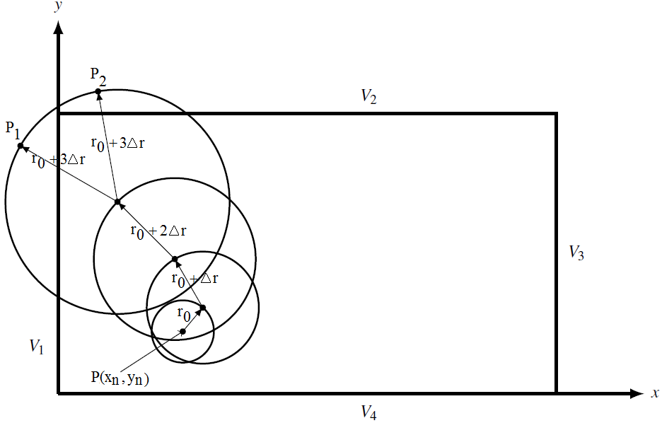

**Fig. 1. Increased-radius floating random walk for an arbitrary rectangular region.**

**3.2. Algorithm for Axisymmetric Region**

The algorithm for axisymmetric region is quite similar to the rectangular case. Because of line of symmetry, two considerations must be taken into account for axisymmetric regions [10].

1. If a step lies on the left side of the line of symmetry, the point is reflecting back to the right side.

2. If a step lies on the line of symmetry, the next step must have angle (ϕ) as such that -π < ϕ < π.

**3.3. Algorithm for Three-Dimensional Rectangular Region**

Similar to the original algorithm, the modified version of the algorithm for a three-dimensional rectangular solution region is the same as for the two-dimensional case. Steps in three-dimensional case are performed on spheres instead of circles. The Radius of spheres on the next step is increased by ΔR. The next point on a sphere can be determined by the following equations:

 (15)

In the Eq. (15), R0 is the initial radius of sphere. The radius of sphere on the next step is R0 = R0+ΔR.The title font style must be Times New Roman, and the font size must be 16 points. The title should be bold, and only the first letter of each word should be capitalized. The title must be centered and leave the 12 points spacing after the title. Also, line spacing must be chosen as single. Do not use any indentation in the title. The title of the manuscript should not be written in italics. We recommend using Title style in MS Word, Home, Styles part in the template document.

The title of the manuscript should be a maximum of 3 lines. Do not use hyphenation in the title. If equations should be used in the title, add the equations using MS Word equations. Please do not use MathType or any other Add-ins instead of MS Word equations in the title.

# Illustrative Examples

**4.1. Comparison with Fixed-Radius Floating Random Walk: Example I**

The new walk method described in this paper is compared with fixed-radius floating random walk methods. Methods are compared in terms of speed and accuracy. The methods were implemented on a Core2Duo 3.16 GHz PC. The source codes were written in MATLAB. Example is provided to illustrate the validity for the increased radius floating random walk. The exact solution for the problem can be found in [13]. As shown in Fig. 2, the aim of the example is to solve Laplace’s equation:

 (16)

subjected to the following Dirichlet boundary conditions: V(x,0)=0, V(0,y)=0, V(x,1)=100, V(1,y)=0

The fixed-radius floating random walk and increased-radius floating random walk methods were carried out with 500, 1000, 1500 and 2000 walks. The initial radius of circle r0 for increased-radius floating random walks was chosen as 0.01 and this value is constant for fixed-radius floating random walk. The increment of radius of circle in increased-radius floating random walk was chosen as 0.001. Tolerance value (T) was chosen as 0.005. Every walks in both methods was repeated 10 times. Three typical points were chosen in solution region and the results are given in Table 1. The results of exact solution for these three points are 43.20, 25 and 6.79 V, respectively.

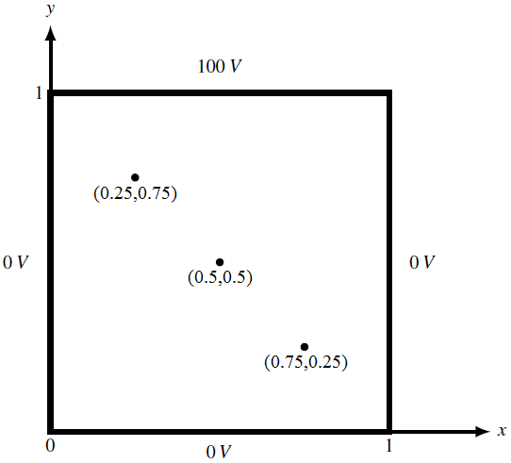

**Fig. 2. Solution region for example I.**

Table 1 presents the solutions for three points. In Table 1, shows the average step size and shows the average runtime values of 10 repeated walk. Random numbers for each walk are different for both methods. The and values are depending on random numbers.

**Table 1. Results for example 1 (r0 = 0.01, Δr = 0.001).**

|  |  |  |  |  |  |  |  |
| --- | --- | --- | --- | --- | --- | --- | --- |
| **Point (x,y)** | ***N*** | **Fixed-radius walk** | | | **Increased-radius walk** | | |
| **Pot. (V)** |  | **(s)** | **Pot. (V)** |  | **(s)** |
| (0.25,0.75) | 500 | 42.16 | 136 | 2.72 | 42.67 | 6 | 0.12 |
| 1000 | 42.92 | 67 | 5.36 | 43.28 | 7 | 0.27 |
| 1500 | 43.69 | 50 | 8.37 | 43.16 | 8 | 0.31 |
| 2000 | 43.50 | 350 | 10.80 | 43.09 | 9 | 0.42 |
| (0.5,0.5) | 500 | 24.88 | 155 | 4.50 | 24.74 | 7 | 0.13 |
| 1000 | 25.22 | 90 | 9.00 | 24.86 | 10 | 0.27 |
| 1500 | 25.10 | 148 | 13.05 | 25.16 | 9 | 0.40 |
| 2000 | 25.35 | 400 | 18.00 | 25.05 | 11 | 0.53 |
| (0.75,0.25) | 500 | 6.76 | 52 | 2.82 | 6.52 | 22 | 0.51 |
| 1000 | 6.85 | 210 | 5.60 | 6.76 | 26 | 1.03 |
| 1500 | 6.80 | 394 | 8.27 | 6.75 | 42 | 1.55 |
| 2000 | 6.78 | 208 | 10.90 | 6.90 | 18 | 2.05 |

Fig. 3, 4 and 5 shows the average run time comparison for three points respectively.

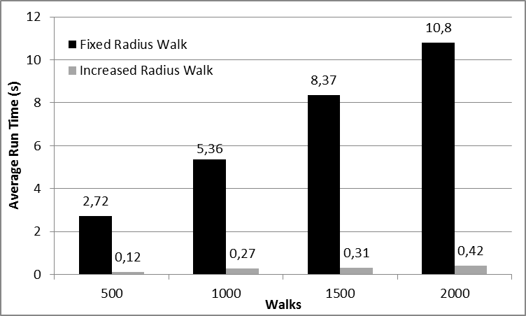

**Fig. 3. Average run time comparison for 0.25 mm, 0.75 mm point.**

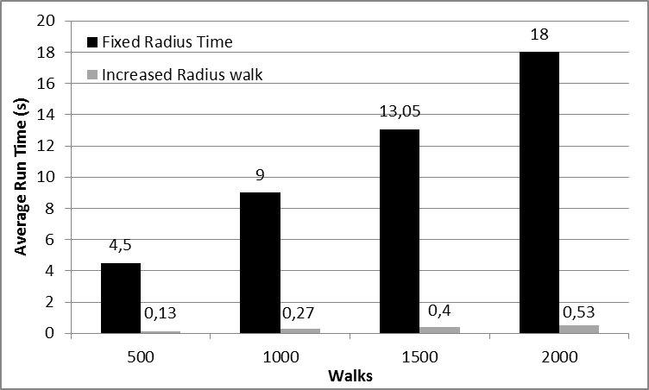

**Fig. 4. Average run time comparison for 0.5 mm, 0.5 mm point.**

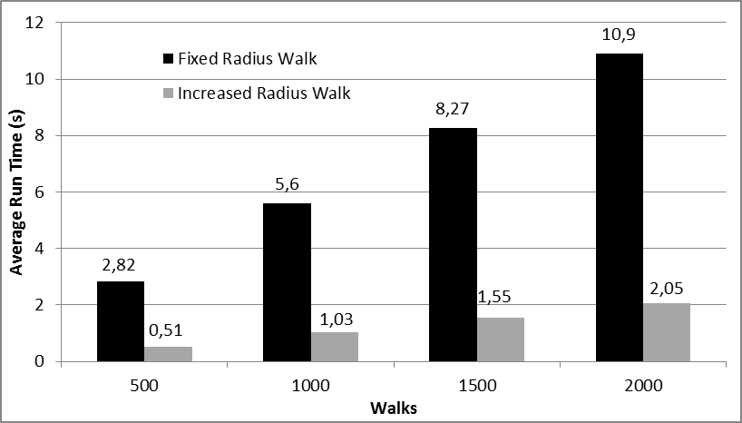

**Fig. 5. Average run time comparison for 0.75 mm, 0.25 mm point.**

Table 1 and Fig. 3, 4 and 5 show that the average step sizes of increased-radius floating random walk are less than that of fixed-radius floating random walk. Hence the runtime are reduced. The runtime is important when the solution points in the solution region are more than one point. In this situation, more than one walk must be started simultaneously. The results are in good agreement with the exact and fixed-radius floating random walk solutions.

**4.2. Comparison with Finite Element Method: Example II**

In addition, the method proposed here was compared with the finite element method. The solution region is also in rectangular coordinates and shown in Fig. 6. The problem is to solve Laplace’s equation with the following Dirichlet boundary conditions:



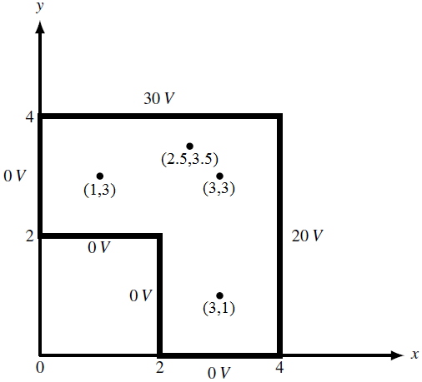

**Fig. 6. Solution region for example II.**

Finite element solution was performed with FEMM software [15]. The mesh created in FEMM model is with 3201 nodes. The results for four typical points are shown in Table 2. The initial radius for increased-radius floating random walk was chosen as r0 = 0.001 and the increment was taken as Δr = 0.0001. The tolerance was set to T = 0.005. Each walk is repeated 10 times and the average values of the steps and time are also shown in Table 2.

As can be seen from Table 2, the results are very close compared with finite element method. The initial radius of circle and the increment value can be chosen as small as possible.

Table 3 shows the potential values at three points for various r0 values. The increment of radius was chosen as Δr = 0.1r0. The number of walks is set to 2000. In Table 3, δ is the error estimate, which is obtained by repeating each calculation 10 times [16]. For the increased-radius floating random walk, it was noted that 2000 walks were sufficient for the solution to converge. It seems from the results that the 0.01 value of initial radius of the circle and the increment value are also sufficient.

**Table 2. Results for example 2 (r0 = 0.001, Δr = 0.0001).**

|  |  |  |  |  |  |
| --- | --- | --- | --- | --- | --- |
| **Point (x,y)** | ***N*** | **FEM** | **Increased-radius walk** | | |
| **Potential (V)** | **Potential (V)** |  | **(s)** |
| (3, 1) | 500 | 8.13 | 8.00 | 45 | 1.26 |
| 1000 | 8.12 | 109 | 2.40 |
| 1500 | 8.14 | 58 | 3.70 |
| 2000 | 8.15 | 74 | 4.94 |
| (3, 3) | 500 | 19.71 | 19.57 | 93 | 1.33 |
| 1000 | 19.60 | 71 | 2.70 |
| 1500 | 19.64 | 80 | 4.03 |
| 2000 | 19.67 | 66 | 5.40 |
| (1, 3) | 500 | 11.57 | 11.53 | 103 | 1.23 |
| 1000 | 11.56 | 77 | 2.47 |
| 1500 | 11.63 | 103 | 3.70 |
| 2000 | 11.52 | 121 | 4.90 |
| (2.5, 3.5) | 500 | 23.93 | 23.63 | 58 | 1.16 |
| 1000 | 23.80 | 92 | 2.34 |
| 1500 | 23.75 | 88 | 3.51 |
| 2000 | 23.85 | 59 | 4.66 |

**Table 3. Potential values and error estimates for example 2 (N = 2000, Δr = 0.1r0).**

|  |  |  |  |
| --- | --- | --- | --- |
| **Point (x,y)** | **FEM (V)** | ***r0*** | **Increased-radius walk (*V±****δ***)** |
| (3, 1) | 8.13 | 0.01 | 8.1510±0.029760 |
| 0.001 | 8.1518±0.083900 |
| 0.0001 | 8.0840±0.080030 |
| (3, 3) | 19.71 | 0.01 | 19.6440±0.05710 |
| 0.001 | 19.6740±0.07056 |
| 0.0001 | 19.6920±0.05370 |
| (1, 3) | 11.57 | 0.01 | 11.6310±0.06174 |
| 0.001 | 11.6890±0.09238 |
| 0.0001 | 11.5350±0.13117 |

We recommend using the Headings 1 style in MS Word, Home, Styles part in the template document for the first-order Headings. Level 1 Headings must be numbered as 1., 2., 3., etc. Do not forget to use the dot after the number. The first Heading must be written as an Introduction.

Times New Roman font type and 12 points font size should be used for first-order Headings. Headings must be written in bold and justified on the page. The first letter of each word should be capitalized. Before the first-order Headings, a 24 points space must be left, and 18 points space must be left after the first-order Headings. Line spacing must be chosen as single, and indentation must be 0.8 cm selected as Hanging. Do not leave only Headings at the end of the pages.

# Conclusions

A new walk method for Monte Carlo method has been implemented in this paper. The method has been applied to Laplace’s solution in rectangular region in two dimensions. It can be easily applied to other coordinate systems and three dimensional cases. The results obtained from the new walk method are in good agreement with those obtained using finite element solution, fixed-radius floating random walk and exact solution methods. The advantages of the new method can be summarized as follows:

1. Runtimes are reduced considerably.

2. The user can choose the initial radius of circle very small.

3. The implementation of the algorithm will be very suitable for multi-point calculations performed at the same time.

4. It will be very useful when starting one more particle simultaneously at a given point.

**References**

[1] J. H. Pickles, “Monte carlo field calculations,” Proceedings of the Institution of Electrical Engineers, vol. 124, no. 12, pp. 1271- 1276, 1997.

[2] W. Yu, K. Zhai, H. Zhuang, and J. Chen, “Accelerated floating random walk algorithm for the electrostatic computation with 3-D rectilinear-shaped conductors,” Simulation Modelling Practice and Theory, vol. 34, pp. 20–36, 2013.

[3] K. Chatterjee, “A Parallelized 3D floating random-walk algorithm for the solution of the nonlinear poisson-boltzmann equation,” Progress in Electromagnetics Research, PIER, vol. 57, pp. 237–252, 2006.

[4] R. Sotner, A. Lahiri, A. Kartci, N. Herencsar, J. Jerabek, and K. Vrba, “Design of novel precise quadrature oscillators employing ECCIIs with electronic control,” Advances in Electrical and Computer Engineering, vol. 13, no. 2, pp. 65-72, 2013.

[5] O. A. Mousavi, M. S. F. Astaneh, and G. B. Gharehpetian, “Improving power system risk evaluation method using monte carlo simulation and gaussian mixture method,” Advances in Electrical and Computer Engineering, vol. 9, no. 2, pp. 38-44, 2009.

[6] M. N. O. Sadiku, “Monte carlo methods in an introductory electromagnetic course,” IEEE Transactions Education, vol. 33, pp. 47-50, 1990.

[7] M. N. O Sadiku, C. M. Akujuobi, and S. M. Musa, “Monte carlo analysis of time-dependent problems,” in Southeastcon’ 06 Proceedings of the IEEE, 2006, pp. 7-10.

[8] W. Yu, K. Zhai, H. Zhuang, and J. Chen, “Accelerated floating random walk algorithm for the electrostatic computation with 3-D rectilinear-shaped conductors,” Simulation Modelling Practice and Theory, vol. 34, pp. 20–36, 2013.

[9] R. C. Garcia, and M. N. O. Sadiku, “Monte carlo fixed-radius floating random walk solution for potential problems,” In Southeastcon ’96. Bringing Together Education, Science and Technology Proceedings of the IEEE, 1996, pp. 88-91.

[10] G. E. Zinsmeister, and J. A. Sawyerr, “A method for improving the efficiency of monte carlo calculation of heat conduction problems,” Journal of Heat Transfer, vol. 96, pp. 246–248, 1974.

[11] G. E. Zinsmeister, and S. S. Pan, “A modification of the monte carlo method,” International Journal for Numerical Methods Engineering, vol. 10, pp. 1057–1064, 1976.

[12] M. N. O. Sadiku, Monte Carlo Methods for Electromagnetics, CRC Press, 1st Ed., 2009.

[13] M. N. O. Sadiku, Numerical Techniques in Electromagnetics, CRC Press, 2nd Ed., 2001.

[14] M. N. O. Sadiku, and R. C. Garcia, “Whole field computation using monte carlo method,” International Journal of Numerical Modelling,” vol. 10, pp. 303–312, 1997.

[15] D. Meeker, FEMM (Finite Element Method Magnetics), www.femm.info

[16] B. Bowerman, and R. T. O’Connell, Applied Statistics, The McGraw-Hill Companies, Inc., 1997.

1. Corresponding Author

   E-mail Address: aihsan.canakoglu@dpu.edu.tr